Project Identification

Project: | Breadmin
Prepared By: | Nooran El-Sherif, Sean Price, Dylan Roberts
Document Version: | 0.2
Published Date: | October 4, 2017

Contributors
The following individuals contributed to this document.
Name | Title
Nooran El-Sherif | Database and back-end developer
Sean Price | Team Lead

Distribution
This document is distributed to all the following people.
Name | Title
Anjana Shah | Professor
Jan Streekstra | Stakeholder / Lead Baker at Forno Cultura

Referenced Documents
This document refers to the following materials
Version number | Title | Author | Date | Source / Location

Revision History

Version Number | Revision Date | Summary of Changes | Modified by
0.2 | 2017-10-04 | Added information, added business context diagram | Nooran El-Sherif
[Note: It is recommended that drafts be numbered 0.1 to 0.9, and that the first approved version be numbered 1.0. Thereafter, new version numbers will depend upon changes: 1.01, 1.1, etc for minor updates, 2.0, 3.0 etc for major changes.]

TABLE OF CONTENTS
1. Business Context Diagram 3
2. REquirements Scope Statements 4
3. High Level Business Requirements (HLR) Traceability 4
4. High Level Business Requirements Sign-Off 5

- Business Context Diagram
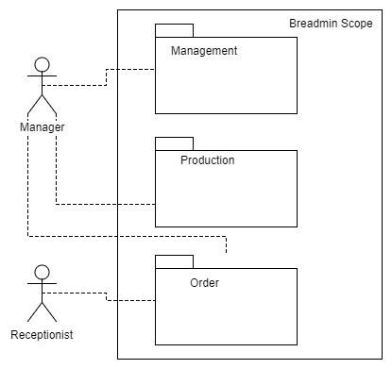

Requirement Scope Area | Description
Breadmin Scope | In scope: management, production, and order functionalities  Out of scope: Inventory and other business processes

External Entity | Description
Receptionist | Forno Cultura receptionist who will access the system to input orders
Manager | Forno Cultura manager who will access the system for production, order and management purposes

Information Flows | Description
Management Information | Analytics and other information from Management to Manager
Production Information | From Production to Manager
Order Information | From Manager to Order
Order information | From Receptionist to Order
- Requirements Scope Statements
HLR# | Description | Priority  (H, M, L)
 | The system must secure exact orders | H
 | The production schedule will be generated from the orders scheduled | H
 | Ordering must be blocked for days where production has reached capacity | H
 | Like orders (orders with products that have been made in previous orders) for the day will be combined into a single amount of product to produce that day | M
 | The manager should be able to perform analytics | M
HLR06 | There should be opportunity for collaboration between members of ordering process | L
HLR07 | Must be an offline component | L

- High Level Business Requirements Sign-Off
The undersigned acknowledge their agreement with the contents of Version <x.x> of the High-Level Requirements document for <Project Name>.

Following approval of this document, requirements changes will be governed by the project’s change management process, including impact analysis and appropriate reviews and approvals, under the general control of the Project Plan and according to company policy. Approved Change Request Documents, if present, will be attached to this Requirements Document as updates.

Name | Project Role and  Functional Area | Date Signed

* Note: physical signatures are not required. Email approvals are acceptable and should be appended to project documents.

